Web Quest Fractals
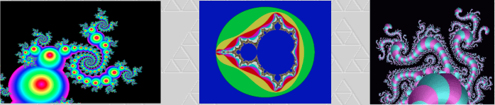
http://math.rice.edu/~lanius/frac/  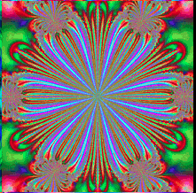 | Page 1  Visit this site on the left and answer the following questions.  1. What is a fractal? Explain in your own words, do not use a definition from a text or website. Your definition must be at least 2 full sentences long.  2. What is important about fractals?  3. Describe how a fractal is made.  4. What is the Jurassic Park fractal? Draw the first 3 iterations of the Jurassic Park Fractal.  5. What is meant by self-similarity? Give some examples of self- similarity in nature.  6. What is meant by infinite perimeter?
http://math.rice.edu/~lanius/fractals/  http://www.shodor.org/interactivate/activities/SierpinskiTriangle/ | Page 2  Explore the Sierpinski Triangle with the linked references on the left. Create a Sierpinski Triangle online using online resources. Follow the directions given for this applet. Print out just the final version. This will be page two.
http://www.wikihow.com/Make-a-Sierpinski-Triangle  http://www.jamesrahn.com/graph%20paper/PDF/triangle.pdf  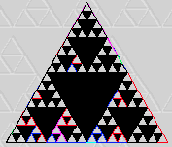 | Use the reference links on the left to find the directions for making the Sierpinski Triangle on paper.  Construct a Sierpinski Triangle on a standard sheet of white 8.5 by 11" piece of paper.  Do four iterations.  Start with an equilateral triangle. Color in the triangles to form a unique pattern.  Each member of the group must turn one in.  Make sure the creator’s name is on the page.
http://www.lifesmith.com/art.html | Page 3  Go to this sight and take pictures of your 3 favorite fractals. Be sure to visit some from recent years as well as some from a long time ago so you can see how they have changed.
http://math.bu.edu/DYSYS/movies.html | Visit this site and explore fractal movies.  Which is your favorite fractal movie? Why?
 | Do a web search. Find another website about fractals that you find interesting. Share it with the other members of your group. What did you learn from this site? Record the URL of this site. Write a 1 page reflection about why you found this site useful and what you learn at this site.

