Try Mr. Whitehead's Tessellation Web Quest
Visit the following site: http://mathforum.org/sum95/suzanne/tess.intro.html and
answer these questions:
1) What is a tessellation?
2) What is tiling?
3) Visit connections to this site that show tessellations and tilings from different
cultures. Which 3 are your favorite? Copy the URL of your 3 favorite sites.
Show your favorites to the other members of your group. 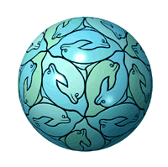
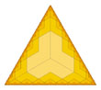
Visit this site http://members.cox.net/fractalenc/encyclopedia.html
Create your own tessellation. Either print it out or save it on your computer to turn
it in as part of your homework

Visit the following site: http://members.cox.net/fractalenc/encyclopedia.html
How can Fractals and Tessellations be related?

Visit the following site: http://www.cromp.com/tess/home.html
Select your three favorite tessallations: Write down the URL and identify your favorites.
Show your favorites to the other members of your group.
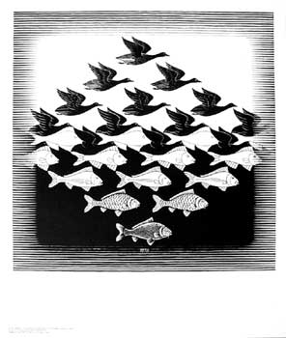
A famous Artist MC Esher used tessellations as part of his art work. Visit this site and select your favorite painting. http://www.worldofescher.com/gallery/
Indicate which is your favorite. Share your favorite with your group.
Do a web search and find 3 sites about tessellations. Record the URL of each site
as well as, what you learned at each site.

