Web Quest- Spirograph | 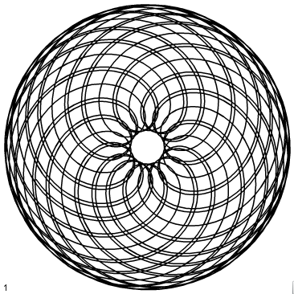

- Make an interesting graph using spirograph. Make only 1 then pass to another group. Cut out your graph, put your name on the back. There is only one spirograph set, so move on with the other parts while you are waiting for the manipulatives. Measure the radius of the outer gear in mm (this is R), the radius of the inner gear in mm (call this r), measure the distance from the center of the hole that you used to the center of the gear that contains it (this is pen position p)
Note: if the smaller gear is inside the larger gear then r is negative. If the small gear is going around the outside of the larger gear then r is positive.

Plug those values into this equation

x(t)=(R+r)cos(t) + p*cos((R+r)t/r)
y(t)=(R+r)sin(t) + p*sin((R+r)t/r)

- Visit this site and make at least 10 different spirograph equations. Take screen shots of each. http://www.mathplayground.com/Spiromath.html (make sure to include A, Radius B and pen position for each of these graphs in your screen shot – scroll down if needed) Try different values such as one of the radii negative and different pen position. For fun try using different colors

- Determine your 3 favorite graphs from step 2 based on ones that look interesting. Paste these into a pages document (be sure to include radius A, radius B and pen position as you will need it later).
(note: you will have one favorite graph done by hand in part 1 and 3 favorite graphs from part 2)

- Graph the equations that you found on https://www.desmos.com/calculator

Make sure that your calculator is in degrees. To graph a parametric equation on desmos type the equations in as a point ((R+r)cos(t) + p*cos((R+r)t/r, (R+r)sin(t) + p*sin((R+r)t/r))

Use sliders in the place of R, r and p to generate a range of graphs on Desmos similar to the ones that you created in step 2.

4. Click on the link: Where’s the math? Give an example of an object that would trace out a spirograph path in real life.
Visit this site:
http://www.personal.psu.edu/dpl14/java/parametricequations/spirograph/
5. Write down the equation for your 3 favorite graphs in question 2 as well as the equation for your favorite graph in part 1. Use the information for radius A, B and Pen position from part 2 and substitute those into the provided equation. Include this information on the pages document that you created in step 2. Leave a blank space to add your graph from step 1.

