Web Quest Spirograph
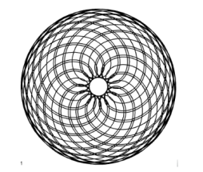
- Make an interesting graph using spirograph. Make only 1 then pass to another group. Cut out your graph, put your name on the back. There is only one spirograph set, so move on with the other parts while you are waiting for the manipulatives. Measure the radius of the outer gear in mm (this is R), the radius of the inner gear in mm (call this r), measure the distance from the center of the hole that you used to the center of the gear that contains it (this is pen position a)
Note: if the smaller gear is inside the larger gear then r is negative. If the small gear is going around the outside of the larger gear then r is positive. Be as accurate as possible with your measurements as even a tiny inaccuracy will completely change the graph.
Plug those values into this equation
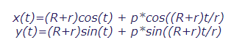
(((R+r)*cos(t)+p*cos((R+r)*t/r)),((R+r)sin(t)+ p*sin((R+r))*t/r))))

- Visit this site and make at least 10 different spirograph equations. Take screen shots of each. https://nathanfriend.io/inspiral-web/
Record the ratios of the gears and the pen position
Take screen shots of your 3 favorite graphs

- Go to https://www.desmos.com/calculator Create an equation using the vector form of the equation given above. Parametric equations are entered in a vector form on Desmos. Type the equation in carefully. Copy and paste does not work well because Desmos does not recognize many fonts which creates a problem
Create values for R and r with the same ratios as the gears that your created. Use sliders for R, r and a to help you find the equations.

- Include screen shots of your favorite 3 graphs plus their equations. Select good colors for the pen and the background to make your graph look attractive. You can either graph them on the same graph or different graphs which ever you think looks better.

- Click on the link: Where’s the math? Give an example of an object that would trace out a spirograph path in real life. Visit this site: http://www.personal.psu.edu/dpl14/java/parametricequations/spirograph/

